AUTO-FLAPS
It is possible to remove the command “AUTO-FLAPS”.
When this command is disabled, the flaps are in position MANUAL and will be operated manually.
Open Plane-Maker. Click on "FILE", then "OPEN". Open the folder containing the F16, then click "F16.acf.
Click "EXPERT" then "special equipement".
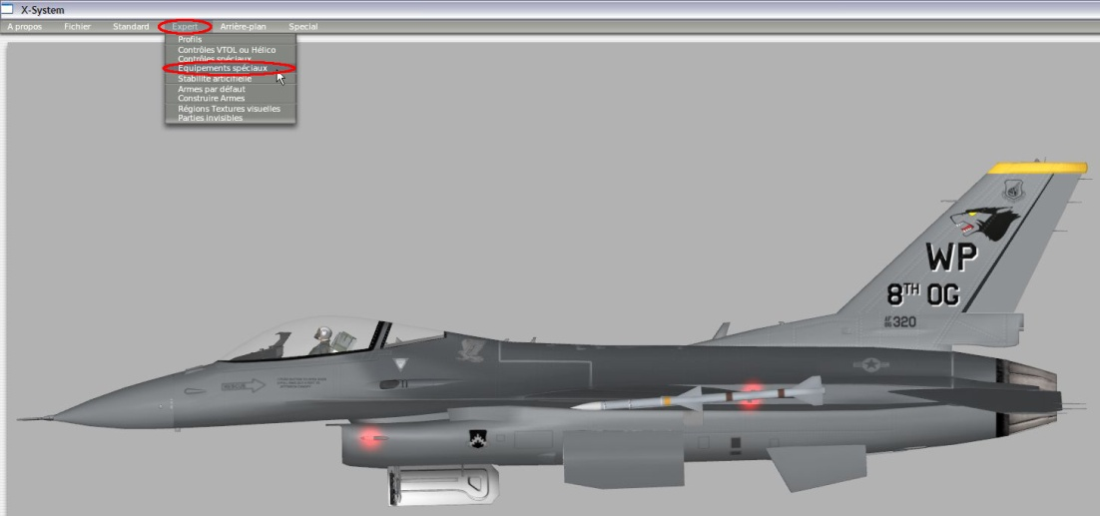
Uncheck the "AUTO GEAR WITH FLAPS.

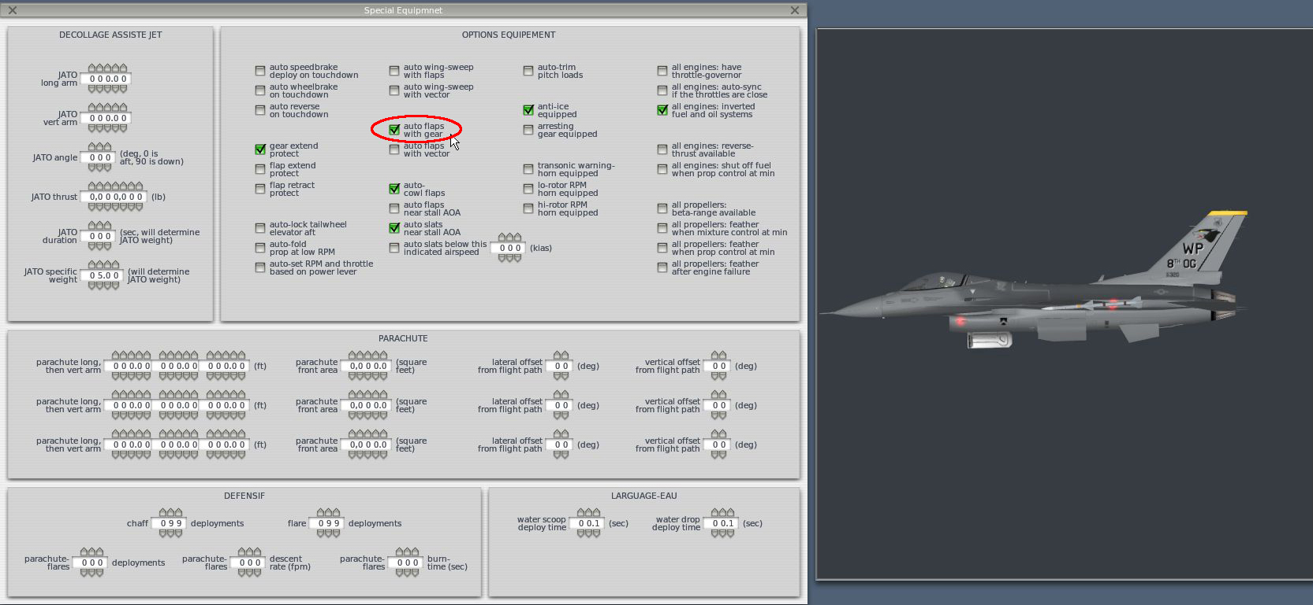

Before any changes, consider making a backup.
Good flights!

